How to upgrade firmware using IVMS Client
- Make sure the device is online, and right click the device to find Device Upgrade.
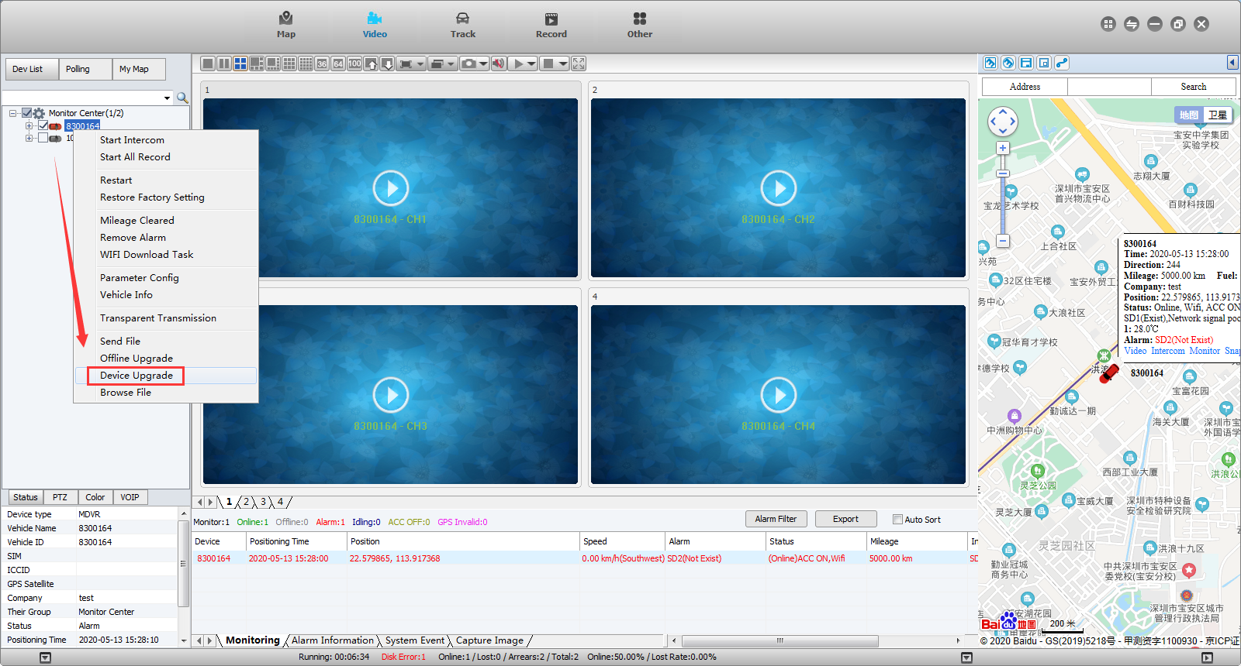
- Select firmware and then choose the path to find the target firmware version. And make sure the format of the version is .CRC format, normally, we send the compression to protect the firmware.
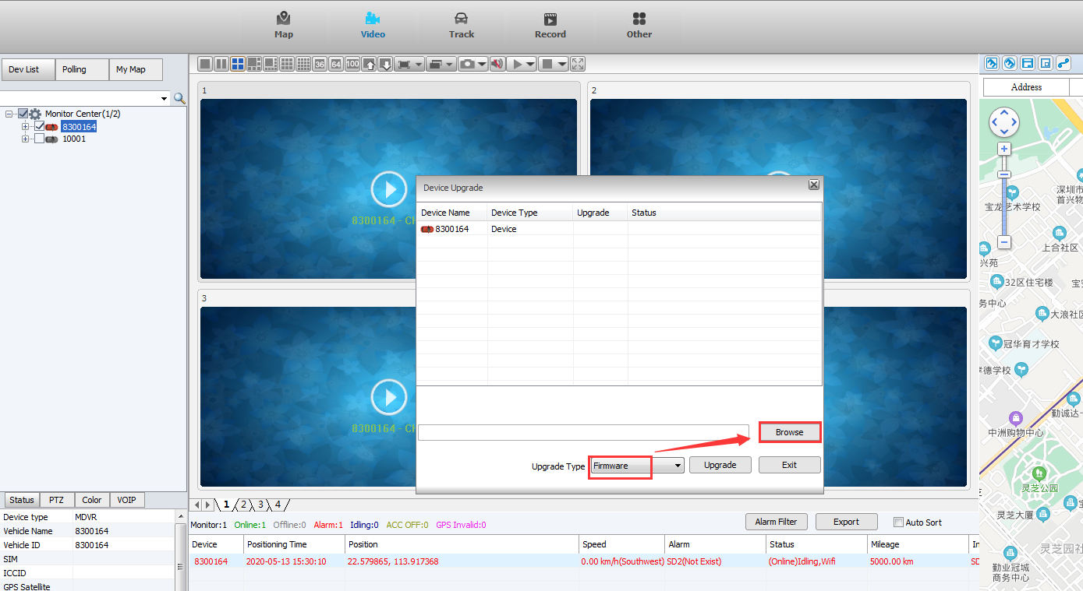
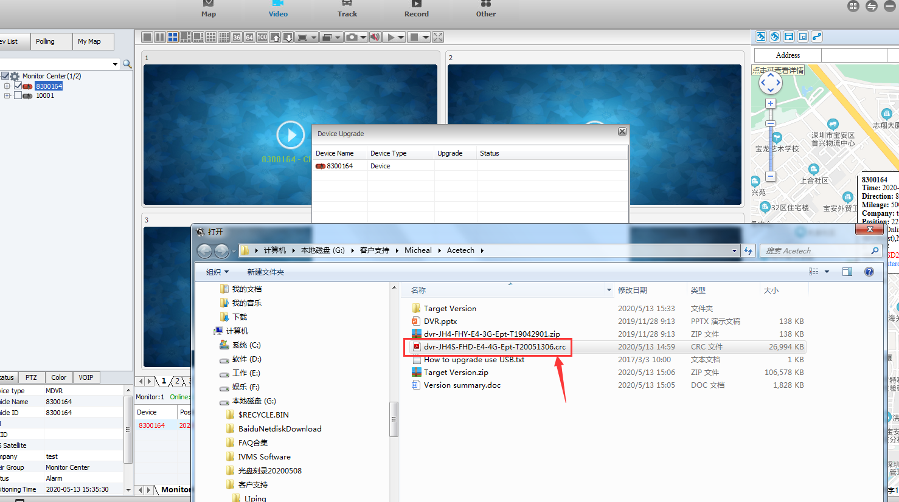
- After choose the correct, then click upgrade and you can see if the firmware is uploaded completely, if uploaded normally, then if will automatic upgrade the firmware.
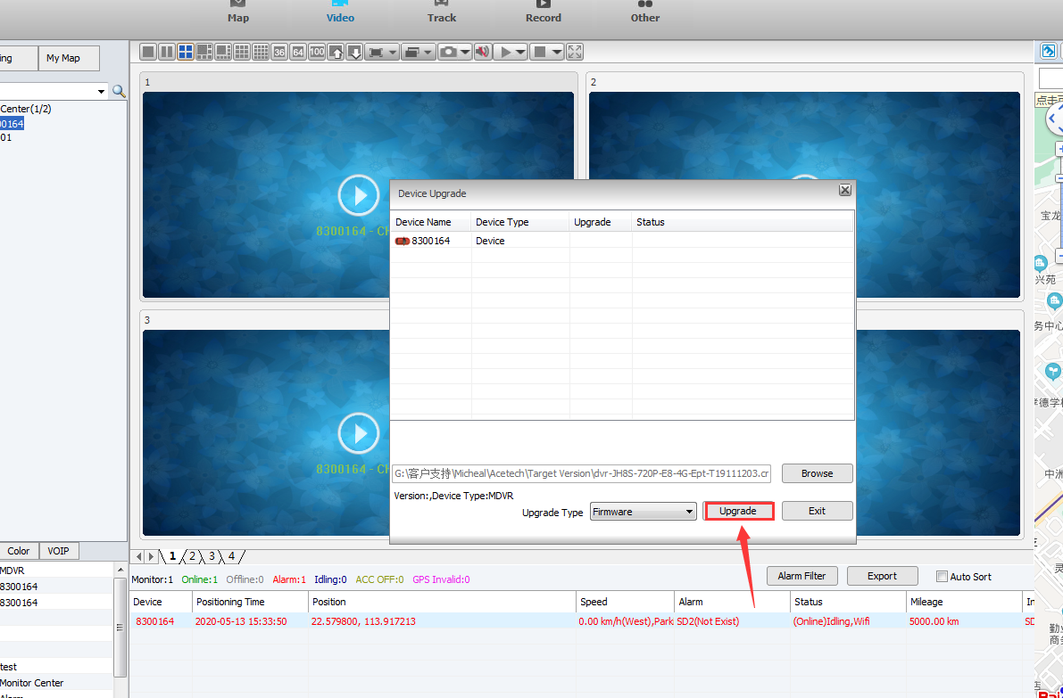
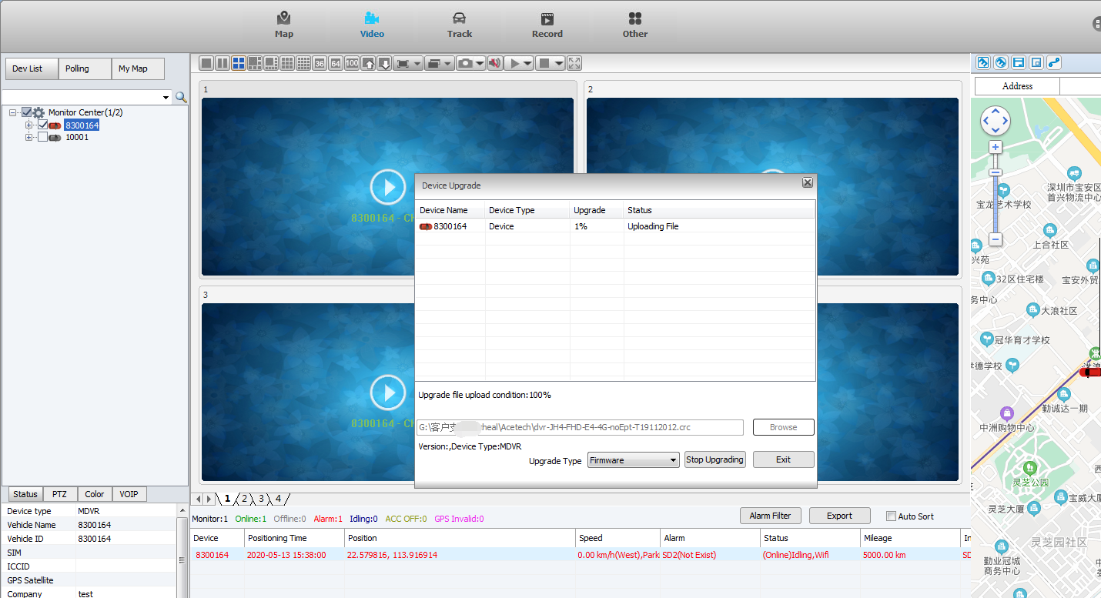
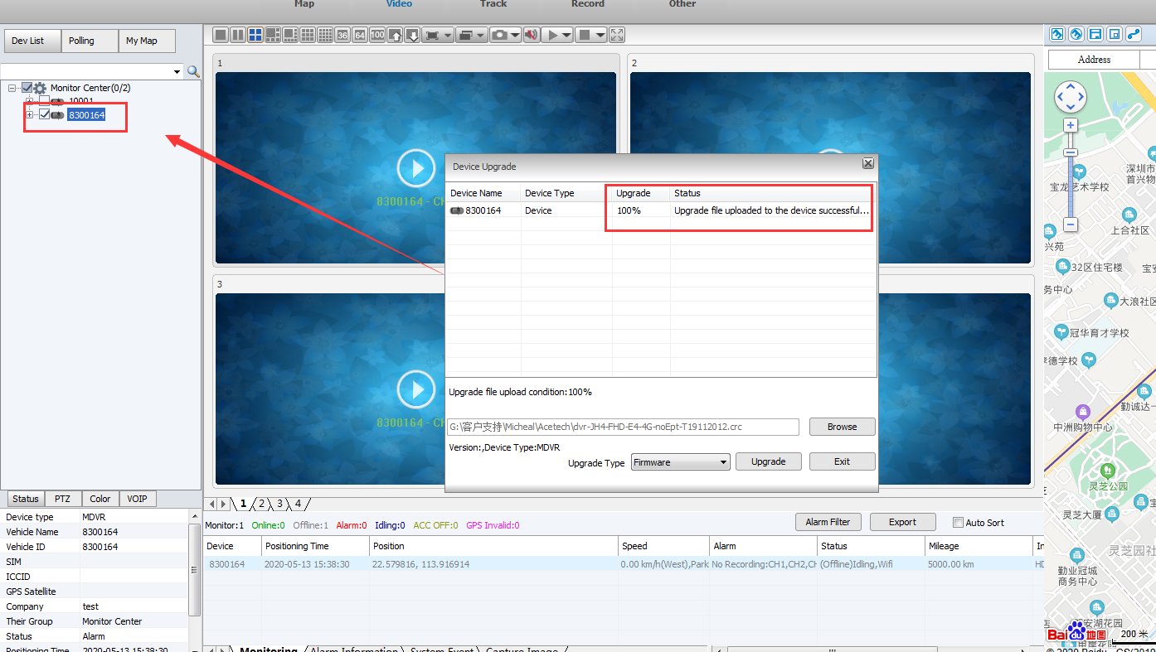
4.When upgrade is showing successful, you can check if the device shows the logo of upgrading...And attention that during the upgrade process, please make sure the device is always online, this is very important, otherwise it will make device upgrade failed.
